This document is merely to point out the differences in confessional count numbers between my findings and the official numbers posted on Survivor Sucks. The guidelines I use can be found [here](https://docs.google.com/document/d/18ofsPiVWxSejzSjEGlU8KEx4Og2ddEJScCV23RsCPIA/edit?usp=sharing).

**Note:** Survivor Sucks Season 29 Counts were changed after the season aired in the front page because of some revisions so there wasn’t a chart created for it with the original numbers. However, I did copy the original numbers before the revisions so I will be referencing them. Also, here’s the [Sucks Season 29 Confessional Thread](http://survivorsucks.com/topic/115970) where those original numbers can be found as the episodes aired.

**My Season 29 Counts** ([link](https://goo.gl/photos/Zyzz6HcTWVgv9NCKA))

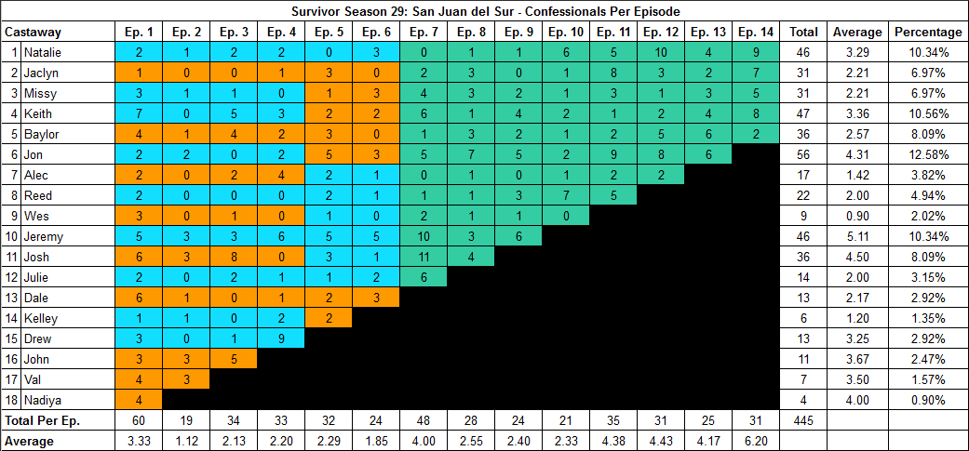

**Differences**

[Episode 01](https://docs.google.com/document/d/1AyT9HDaphV-lTu3hZaOYTR5NkdiasC2R5Jf3ajlvaBY/edit?usp=sharing)

* **Nadiya: 4 (-1)** Confessional #28 has a 9s gap.
* **Drew: 3 (+1)** Confessional #39 has a 10s gap.
* **Josh: 6 (+1)** Confessional #56 has an 11s gap.

[Episode 05](https://docs.google.com/document/d/1mOckDu4ZSUIgK2kGnYW-7yBngc7vI0taEPzzQEELOQ8/edit?usp=sharing)

* **Kelley: 2 (-1)** No significant gap (9-11s).

[Episode 06](https://docs.google.com/document/d/1UViSP7cI6CNsJD1PwV0LXonTBO4wFJ2NV2L6xIdXA4g/edit?usp=sharing)

* **Natalie: 3 (+1)** Confessional #12 has a 10s gap.
* **Dale: 3 (-1)** Confessional #21 has a 9s gap.

[Episode 07](https://docs.google.com/document/d/1IIejbyo7xiZU4KnBoYDsAfLlgiNHo6FWoja3-bCOKYM/edit?usp=sharing)

* **Josh: 11 (+1)** Confessional #21 has an 11s gap.

[Episode 09](https://docs.google.com/document/d/19uIQUhDXZNofYMaF-eYHWgqtJb9PNuumBntMml8VjVk/edit?usp=sharing)

* **Jeremy: 6 (+1)** Confessional #12 is a voice over and also has a 12s gap with #13.
  + **Note:** Confessional #13 has segments of “confessional time” and “on the fly.”

[Episode 10](https://docs.google.com/document/d/1bXZMTzzYapOjgYlEEXyDrxS9u_3QZ2io6U402_5vSHw/edit?usp=sharing)

* **Reed: 7 (+1)** Confessional #18 has a 12s gap.

[Episode 11](https://docs.google.com/document/d/1Ub9vkI-bIE3c6telBXlUFjPtd2XtneUi3xjPj0F0nUs/edit?usp=sharing)

* **Jon: 9 (+2)** Jon has a troublesome group of consecutive confessionals (#7-10) that could be analyzed in different ways and give different quantities, either 4 (my count) or 3 (-1).
  + Between confessional #7 and 8 there’s a 12s gap. **Note:** Confessional #7 has Jon next to a tree at the beach (Exile Island) and #8 starts wit him in the jungle.
  + All of confessional #8 has Jon sitting next to a tree at the beach (EI) mixed with voice over segments.
    - (13:58 → 14:07 = 9s) This 9s gap corresponds to an over the shoulder shot at the clue as Jon reads it out loud. I didn’t include this as part of the confessional, but having the 9s gap doesn’t change the outcome.
    - (14:13 → 14:15 = 2s) After this 2s gap there is a voice over of Jon reading the rest of the idol clue (*“...It's a drier trek at least twice a day...”*). It is questionable whether this should be included in the confessional because it is a continuation of the above mentioned over the shoulder shot where Jon reads the clue out loud. Because of this, I didn’t include it.
      * Having said that, if that voice over of the idol clue being read out loud is included, there is a 9s gap (14:17 → 14:26 = 9s) from the moment he is done to the continuation of the next confessional segment which would bring down his count to 3 (-1).
    - (14:13 → 14:26 = 13s) This 13s gap includes the above mentioned voice over of Jon reading the idol clue out loud which goes directly into confessional #9.
  + The gap between confessional #9 and 10 is over 15s.

[Episode 12](https://docs.google.com/document/d/1imyozAhsPXDNrqZ4kqIZaGP4eoDC4iyADxLvDmWoQzE/edit?usp=sharing)

* **Jon: 8 (+1)** Confessional #20 has a 15s gap. This is the only significant gap.
* **Natalie: 10 (+1)** Confessional #28 is a voice over and also has an 11s gap with #29.

[Episode 14](https://docs.google.com/document/d/1UEsTrte9VQHucP-utHi5OdqzL7JhPANwUjwuN86Cb48/edit?usp=sharing)

* **Jaclyn: 7 (-1)** Confessional #21 has a 9s gap.
* **Keith: 8 (+1)** Similar to Jon’s confessional from Ep11, this is a troublesome group of consecutive confessionals (#9-11) that could be analyzed in different ways and give different quantities, either 3 (my count) or 4 (+1). For context, all voice overs were included. Not included: any time Keith read a clue or reacted to practicing in the challenge.
  + Confessional #9 includes an interview. Gap is longer than 15s with #10.
  + Confessional #10 includes an interview. Gap is 13s with #11.
  + Confessional #11 includes interview segments with one “on the fly” voice over.
    - (23:33 → 23:37 = 4s) At the end of this gap, there is an “on the fly” voice over which has a different pitch from the rest of his interview confessionals and that’s why I identify it as on the fly. However, because it is a voice over, I included it. The voice over is followed by this gap (23:41 → 23:47 = 6s) that continues with more voice overs from the interview. As evidenced, all gaps are less than 10s.
      * Having said that, if the on the fly voice over is not included, the gap becomes (23:33 → 23:47 = 14s) a 14s gap and would constitute a new confessional.

**No Change**

* [Episode 02](https://docs.google.com/document/d/13yELxaCjf8XXA1HxdGr9RFtMqTkViYphb5o6z_6BspM/edit?usp=sharing)
* [Episode 03](https://docs.google.com/document/d/11uEUTuexJCFhoMrbX-SiVjuYcKbL6-DYLqL-imNGM5Q/edit?usp=sharing)
* [Episode 04](https://docs.google.com/document/d/1tTwUCJ4AGsWzOd0FCkkzTRkRB3DiW3vgL6pAvJytpoE/edit?usp=sharing)
* [Episode 08](https://docs.google.com/document/d/1W7xy6RiRPQKlNgcx-ZMwk4eLOE0EVHxy60OKzfs-Y5Q/edit?usp=sharing) (**Note:** Confessional #14 has segments of voice overs and “on the fly.”
* [Episode 13](https://docs.google.com/document/d/1IHBO3hE0BxPYx6I-rF6PYS8XE0hBkWVm54c4_IgJcVk/edit?usp=sharing)

|  |  |  |
| --- | --- | --- |
| **Castaway** | **Count** | **Change** |
| Nadiya | 4 | -1 |
| Drew | 13 | +1 |
| Kelley | 6 | -1 |
| Dale | 13 | -1 |
| Josh | 36 | +2 |
| Jeremy | 46 | +1 |
| Reed | 22 | +1 |
| Jon | 56 | +3 |
| Keith | 47 | +1 |
| Jaclyn | 31 | -1 |
| Natalie | 46 | +2 |
| **Total** | **445** | **+7** |

**Revised Sucks Confessional Counts** ([link](https://goo.gl/photos/9fwXPmCgpxwMSReZA))

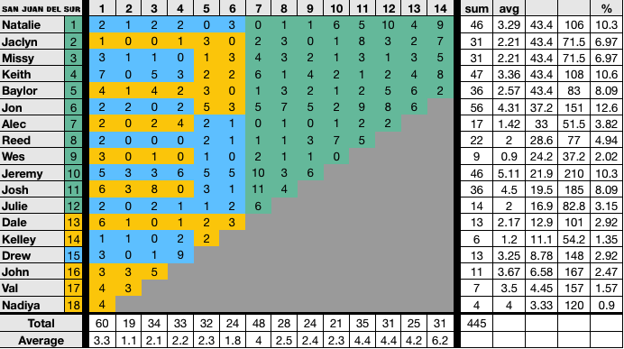

**Differences:** None. All my findings are reflected in the verified counts.